**Assignment 3**

**Due: Wednesday March 29, 2023 at 11.59 pm**

# **Part A) Explore Vi**

1. What are the 3 modes of vi? Explain the role of the modes. [1.5 marks]

**A: Insert mode, command mode, visual mode**

**Insert mode allows text editing.**

**Command mode allows user to move the cursor, copy, paste, etc.**

**Extended command mode allows user to use commands like :wq, search, etc.**

1. How you can exit vi and save the file at the same time? [.5 marks]

**A: :wq**

1. How can you save a file without exiting vi? [.5 marks]  
   **A: :q or :q!**
2. How can you turn on line numbering in vi? [.5 marks]

**A: :set number**

1. How is “copy and paste” and “cut and paste” performed in vi? [1 marks]

**A: Copy is used with yy and paste with pp. Cut is used with dd and paste with pp.**

1. What is *tr* used for? Explain and provide an example. [1.5 marks]

**A: tr in the terminal can be used to replace characters in a file.**

**EG: cat file.txt | tr [:lower:] [:upper:] will replace all lower case characters with uppercase.**

1. The vi editor’s ____ mode is started by pressing Esc. [.5 marks]

a)edit

b)insert

c)ex

d)command

**A: Command mode**

**Part B: Advance file processing command**

1. What is the use of the umask command? Provide an example. [2 marks]

**A: The umask command changes default permissions for newly created files and directories.**

**E.g. umask 077, all newly created files the user will have read and write permissions, group and other will have no permissions.**

9. Your boss has two salary scale files, salary and salary1, and wants to compare their contents side by side to see if there are any differences in the files. Which of the following commands should he use?1  
[1 marks]

a. diff -S salary > salary1

b. comm salary salary1

c. uniq salary < salary1

d. sed --comp salary salary1

**A: b. comm salary salary1**

10. Your boss is trying to delete the word “difficult” as it appears in a text file containing his speech about motivation. The name of the file is motivate. When he decides to use the tr command to delete this word, it instead deletes characters throughout the text. Which of the following commands is he likely to have used?1 [1 marks]

a. tr -d "difficult" < motivate

b. tr difficult motivate

c. tr -o 'difficult' > motivate

d. tr --eliminate difficult motivate

**A: a. tr -d ‘difficult’ < motivate**

# **Part B) File Manipulation in Linux [10 marks]**

11.Create a directory under your home directory and name it **CPAN133-Assignment3**.

1. Create two sub-directories name them: **prof-info** and **student-info.**
2. Access the directory named CPAN133-Assignment3**.** Create two empty files named professors.txt and students.txt.
3. Use redirection operators and change the content of professors.txt and students.txt:

professors.txt students.txt

------------- ------------

Fujimara Anderson

Bolosky Jones

Ribisi Hernandez

1. In the previous question did you use input redirection or output redirection? Explain.

**A: I used output redirection. I used cat > ‘filename’ to enter the contents into the file.**

1. Use the paste command to combine professors.txt and students.txt sided by side and save it in a file named prof-stu.txt**. (submit the command)**

Fujimara:Anderson Bolosky:Jones Ribisi:Hernandez

**A: paste -d “:” professors.txt students.txt > prof-stu.txt**

1. Sort prof-stu.txt in alphabetical order based on the professors’ name and store the result in a file named sorted-prof-stu.txt. **(submit the command)**

**A: sort prof-stu.txt > sorted-prof-stu.txt**

1. Create a directory named **academic-info**.
2. Move sorted-prof-stu.txt under the **academic-info** directory. **(submit the command)**

**A: mv sorted-prof-stu.txt academic-info**

1. Access the CPAN133-Assignment3 directory. Issue a command to create a **hard link** named (link- academic-info) to the file sorted-prof-stu.txt which resides under the academic-info directory
2. Display the long list of all of the files and directories. **(attach the screenshot)**

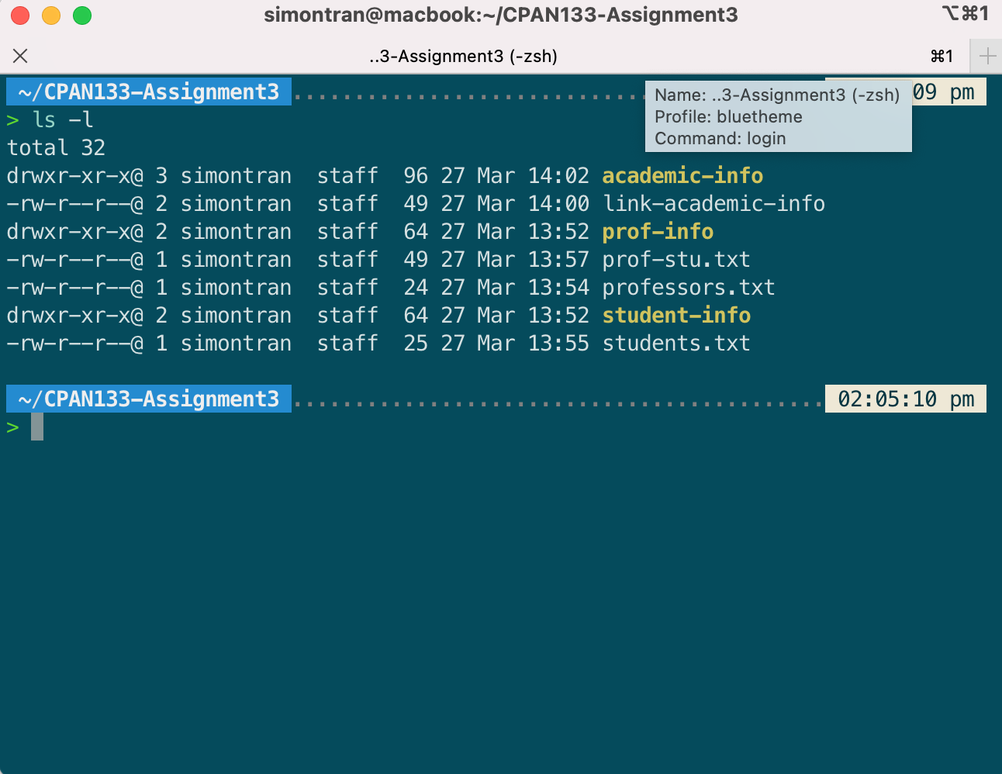

# SUBMISSION GUIDELINES

* 1. Submit a **pdf** containing your answers to the questions on the submission link (**Submission of Assignment3**) under the *Assignment Submission* Folder on Blackboard.
  2. Your document should contain your information: full name, student id and, section number.
  3. If you have any questions regarding the submission guideline ask your instructor.

**LATE SUBMISSION** will be penalized 5 % per day up to 5 days.

1This exercise is from: **Palmer, Michael J. *Guide to UNIX using Linux*. 4th ed. Boston, MA: Course Technology, 2008. Web**